Dr.Surendra Kumar

Concept of Economic Growth and Development : Measurement Part 2
There are several criteria or principles to measure the economic development yet none provides a satisfactory and universally acceptable index of economic development. Hence, it is complex problem to answer about the measuring of economic development. R.G.Lipsey maintains that there are possible measures of a country’s degree of development, income per head , the percentage of resources unexploited, capital per head, saving per head and amount of social capital. But more commonly used criteria of economic development are increase in national income, per capita income, comparative concept, standard of living and economic welfare of the community etc.
In the earlier lessons of measurement we have discussed the various measurement concepts here we will get to know about the comparative concept.

Comparative concept:-
Economic development is a comparative concept and it can easily be understood and measured. In a simple way, from comparative concept, we can ascertain how much the economic development has been attained in a country.
The comparison can be made by two methods over time period:
(а) Comparison within the country.
(b) Comparison with other countries.
(a) Comparison within the Country:
To compare the economic development of a country over time, we will have to consider the long period and divide it into different phases. For instance, national income in 1990 is Rs. 1,000 crores which rose to Rs, 1,200 crores in 1995 and Rs. 1,800 crores in 2000.
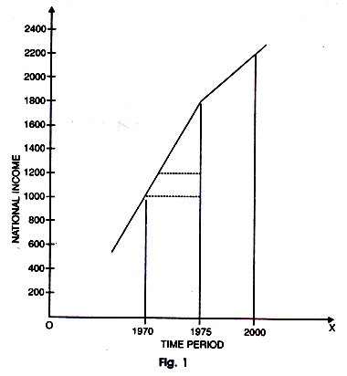
In 2000, it has been registered of amounting Rs. 2,250 crores. Therefore, within the period of five years i.e., from 1990 to 1995 national income increases to the extent of 20 percent (200×100/1000=20%). Form 1995-2000, it rose to 50 percent (600×100/1200) and from 1995-2000, it rose 25 percent (450×100/1800=25%). This can also be drawn with the help of diagram.
The above stated figure exhibits that national income in 1990 was Rs. 1,000 which rose to Rs. 1,200 crores in 1995 and Rs. 1,800 crores in 2000: Therefore, rise in national income over five years period is 20 percent, 50 percent and 25 percent respectively.
(b) Comparison with Other Countries:-
In this Figures 2 time, is shown on the horizontal axis and national income on vertical axis OY. The curve PP’ depicts the path of development (showing slow rise in income) of country MM’ curve shows the path of development of country B.
In the beginning of the time periods, country B is at a much higher level of national income than country A.But in the meanwhile, the rate of development of country A becomes higher than rate of development of country B. At point E i.e., time period 5, national incomes of both the countries are equal.
In the long run or after time interval, national income of country A becomes higher than of country B. In this way, we can say that country A is more developing economy and country B is a comparatively decaying economy.
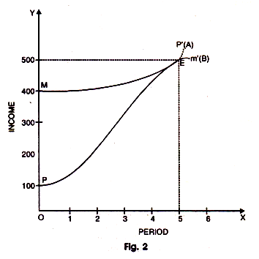

The various methods are inter related and are inter dependent. After summarizing the discussion we can say that ‘percapita income’ can regarded as the best available suitable criterion for developing countries while ‘national income index’ is well suited to advanced countries.

